the problem to be evaluated, not merely a formatting inconvenience before reasoning begins.
We considered LATS-RCA together with RCAEval, AIOpsLab, Flow-of-Action, and MicroRCA-Agent. These works address repeatable evaluation, interactive operations, controlled tool use, and preparation of multiple evidence modalities. LATS-RCA adds an explicit search over alternative explanations. In our original Autonomous CI/CD Incident Triager and Self-Healer proposal, this is most relevant to the AI Incident Analyzer and RCA Engine. We could investigate hypotheses using a wider record of Git commits, pull requests, pipeline outcomes, deployments, configuration changes, and service health. The purpose would be to identify the change or dependency that explains the failure, as well as the service showing the symptom. This remains a design opportunity that needs evaluation; the published results do not establish the performance of such an extension.
The cost results also shape what we would measure. Alongside root-cause accuracy, we would record investigation time, API and tool calls, token use, and the number of hypotheses considered. If recovery becomes available, we would add successful and incorrect remediation outcomes and recovery time. We found LATS-RCA useful because it presents both the benefit of broader hypothesis exploration and the burden it can place on resources. Its production evaluation further exposes the effect of inconsistent operational data. For RecoverIT, the lesson is to maintain alternatives while keeping collection and reasoning bounded, then report the evidence and resource use clearly enough for a reviewer to assess the trade-off.
2.13 GRAPH-AUGMENTED RCA
Tian et al. (2026) present GALA, a graph-augmented approach to root cause analysis and incident response in microservices. We focused on three problems described in the paper: symptoms may appear away from the initiating service, different telemetry sources may suggest different causes, and an operator needs an explanation and response guidance beyond a service label. The work combines service dependency graphs, telemetry from several modalities, statistical hypothesis generation, and investigation by LLM agents. This is relevant to our effort to connect evidence across sources before recommending a response. The graph supplies relationships between services, while metrics, logs, and traces contribute observations that can be assessed within those relationships rather than as unrelated anomalies.
Metrics provide numerical observations such as CPU usage and latency. Logs describe timestamped events, while traces show calls between services and their timing. The paper uses traces to construct a dependency graph through which an agent can examine how a failure may have propagated. We see a possible extension for RecoverIT in connecting runtime dependencies with software-delivery relationships, including pipelines, deployments, Git changes, and configurations. A symptom in one service could then be assessed alongside the change history of the services it depends on. The GALA+ architecture develops this process through four phases, separating candidate generation from the deeper diagnostic work performed later.
In the first phase, GALA+ generates early hypotheses from metric and trace signals. The second assembles diagnostic packages at pod level, retaining relevant telemetry together with time and dependency context. The third uses the graph to guide the agents' investigation. The fourth turns the investigation into a diagnosis, incident report, and action items. We find the division useful because each stage has a recognisable output for the next stage to examine.
Our broader workflow also separates collection, analysis, hypothesis assessment, planning, and reporting. GALA+ gives us a reference for keeping these stages connected without asking the LLM to interpret every raw record at once. We are particularly interested in its use of two signal sources when generating the initial candidates, before detailed investigation begins.
GALA+ uses BARO for a coarse ranking based on metrics and STRIX for ranking that considers traces and graph structure. It combines the two rankings into a candidate list for further LLM investigation. Logs are used later because some failures produce little useful error text, making them a weak basis for the initial ranking. We took this as a reason to avoid giving one evidence type automatic priority in our own design. A service can be faulty even when its logs are sparse. The pod-level diagnostic package provides another useful idea by bringing the relevant observations together for each candidate while retaining the relationships needed to interpret them.
The diagnostic package condenses telemetry without removing its temporal patterns, dependency information, or useful error signals. This reduces the amount of material the LLM must consider for a particular service or pod. We see the connection with RecoverIT's context builder, which prepares logs, metrics, delivery records, and source changes for reasoning. The summary needs to retain what makes one hypothesis more plausible than another. GALA+ then starts investigation branches for highly ranked candidates in parallel. We view this as an example of directing investigation effort toward defined alternatives, rather than searching every component equally or supplying a model with all operational data indiscriminately.
An Investigator Agent evaluates a candidate using its package and produces an assessment containing a cause, confidence, evidence, and supporting and contradicting factors. If the evidence is insufficient, it explores dependent services in batches. The graph therefore limits the search to plausible propagation paths and gives it a basis for stopping when support is adequate. We want comparable discipline when assessing a failure after deployment. Candidate explanations may include a code defect, a configuration regression, a database issue, resource exhaustion, or an unavailable dependency. The next query should help compare those explanations. We do not want the model to choose the first one merely because it matches a familiar error message.
We would retain those candidates while gathering observations about their timing and dependencies, then rank them according to the support obtained. The paper contrasts graph-guided investigation with limitations of earlier approaches: examining one telemetry packet at a time may omit context, while unrestricted ReAct exploration can drift into irrelevant areas. We interpret the graph as a constraint on reasoning as well as a way to retrieve information. Its relationships suggest where to investigate next and help explain why that direction is relevant. Such a constraint could strengthen our broader proposal, but it would need to be implemented and tested explicitly rather than assumed to follow from having a timeline.
The reported GALA+ AC@1 results are 74.44% on Online Boutique and 73.33% on Train Ticket, exceeding the strongest LLM baselines by more than 25 percentage points in those experiments. On AegisLab, which includes 25 failure modes, the authors report the best MRR, AC@1, and AC@3 among the tested approaches. We treat these as results for the paper's datasets and conditions. They support investigating the combination of graph structure, complementary telemetry, and guided reasoning. They do not provide a transferable accuracy figure for RecoverIT. The paper is also useful because it assesses the generated incident report and action guidance, which are important parts of the output an operator actually receives.
For those outputs, the authors use SURE-Score, an evaluation framework developed with SRE input. It considers the quality and usefulness of incident summaries and recommendations, and the reported human evaluation favours GALA+ over Flow-of-Action on the assessed dimensions. We find this relevant because our final output also needs to help a person review the incident. Correctly ranking a cause is valuable, but the supporting explanation and proposed next step must be understandable and grounded in the same evidence.
2.14 EXCEPTION-BASED RCA
Mhatre and Shaikh (2025) combine an exception classifier with fine-tuned language models to investigate microservice failures. We reviewed the paper for its direct connection between runtime exceptions and application code. Its starting problem is the volume of business and runtime exceptions that engineers would otherwise have to examine manually. The authors organise processing into aggregation, classification, and code-aware RCA using stack traces and repository context. Apache Kafka provides the exception aggregation layer. We find this useful for RecoverIT because a monitoring deviation may reveal little about the code responsible, whereas an exception and the relevant source snippet can offer more specific evidence. The approach provides a software-level view that complements the telemetry and dependency methods discussed elsewhere in our review.
Microservices publish exception messages to a Kafka topic, after which an Exception Classifier preprocesses them and distinguishes business exceptions from runtime exceptions. Runtime exceptions are forwarded to the RCA service. We see a practical reason for that separation: different event categories need different treatment, and some do not require the same depth of diagnosis. Filtering before LLM processing can avoid spending resources on records that do not belong to the investigation. In a future RecoverIT extension, staged processing could distinguish informational events, application errors, deployment problems, and incidents requiring further analysis. The classification would support triage while leaving the explanation of the underlying cause to the investigation stage.
The authors compare XGBoost, Support Vector Machine, and Naïve Bayes with LLM-based exception classification. XGBoost performs best among the conventional models they evaluate. We regard this as another reason to assign the LLM a defined role instead of replacing every existing method with model calls. Deterministic rules or conventional classifiers may handle routine categorisation effectively, while the language model is used where source context and semantic interpretation matter. Our own architecture follows a related separation: operational tools retrieve records, validation prepares them, and reasoning services compare their meaning. We would evaluate any new classifier on its own contribution before adding it to the incident workflow.
The RCA service uses fine-tuned CodeLlama and Mistral models. It receives runtime stack traces and tokenized or preprocessed repository information, then generates an explanation of the cause. The paper reports particularly good results for CodeLlama-7B when it receives preprocessed code snippets. We see the connection with our proposed use of recent Git commits and pull requests. When a failure follows a deployment, code context can help explain why the exception appeared. A stack trace identifies where execution failed, while the relevant code and its recent changes can help test the mechanism behind that failure.
For our investigation, this raises a more specific question than locating the affected service: we also want to understand which code or configuration changed before it failed. The paper's layers map reasonably well to our proposal. Exception aggregation relates to collection, classification supports triage, and the LLM service performs RCA using repository context. RecoverIT's broader evidence set includes metrics, deployments, pipeline outcomes, configuration changes, and health checks as well. We would use these sources to evaluate whether a code-based explanation fits the operational sequence. The useful contribution of the paper is its movement from the location of an exception to analysis of the code and interactions behind it. That connection is important when several different defects produce similar outward symptoms.
Generic HTTP errors, timeouts, or unavailable services may conceal a specific code problem. Providing relevant source snippets gives the diagnostic model more to work with than the exception category alone. The paper reports over 90% precision for business-exception classification, 89.6% recall for runtime-exception classification, RCA processing below one second per exception, and over 85% accuracy in a human qualitative assessment. We keep these measures separate because they describe different tasks and evaluation methods. They indicate potential for fast classification and code-aware diagnosis under the reported conditions. For RecoverIT, speed matters, but we would still need to establish whether a complete investigation across several sources reaches the correct cause.
Our evaluation would therefore extend beyond per-exception processing time. It would consider the accuracy of multiple-source diagnosis, the collection process, and, if implemented later, remediation success, recovery time, and verification reliability. The authors identify related extensions: incorporating environmental logs such as resource consumption and network or disk activity, using feedback to adapt to changing services, and exploring autonomous remediation. These directions overlap with our original proposal to combine application and infrastructure records, metrics, Git changes, deployments, CI/CD evidence, and configurations. We interpret that overlap as a research opportunity rather than evidence that the proposed integration has already been achieved in our implementation or evaluated by the exception-focused study.
We place this work alongside RCAEval's reproducible telemetry cases, MicroRCA-Agent's modality-specific preparation, GALA's dependency graphs, and Flow-of-Action's control of tool use. Each addresses a different part of reliable diagnosis. The exception-based approach contributes a closer connection to source code, which can help explain failures that appear only as general runtime symptoms in other evidence sources.
AIOpsLab adds an interactive setting in which detection, localisation, RCA, and mitigation can be assessed separately. Taken together, these studies helped us connect software-level evidence with the wider incident workflow. We use Mhatre and Shaikh's work specifically for its code-aware diagnostic perspective, while retaining the need for other sources and broader evaluation in RecoverIT.

2.15 HEALTH-PROBE REMEDIATION
Kalakoti (2025) describes a self-healing infrastructure architecture built around health monitoring, AI-assisted diagnosis, and predefined remediation playbooks. We examined it because a health alert identifies a problem without necessarily providing a route to recovery. The proposed loop monitors the service, diagnoses an unhealthy condition, selects a playbook, executes its steps, and checks the resulting state. Kubernetes supplies the infrastructure, with health probes and monitoring records feeding the reasoning and remediation stages. This is relevant to the long-term RecoverIT direction, where we want diagnosis to support a response that can be verified. It also helps us define the limits of the current application, which reads health information and generates advice but does not yet execute recovery playbooks.
Kubernetes liveness, readiness, and startup probes describe different aspects of application health and availability. The framework uses unhealthy results to initiate reasoning and an appropriate remediation procedure. We consider probes useful evidence because they can establish whether the reported symptom is still present and, in a future execution workflow, whether it changes after an action. A probe result alone may not explain the cause, however. We would interpret it alongside logs, metrics, and change records. The paper's combination of reasoning with predefined playbooks offers a way to connect that diagnosis to an operational response whose possible actions have been specified in advance.
Predefined playbooks limit the action space. In our original design, a Recovery Planner would select or describe a response, while a separate executor would restrict operations to approved actions such as a restart, deployment rollback, controlled scaling, component restart, or pipeline retry. We would still need to evaluate the consequences and permissions for each action in its deployment context. Kalakoti's loop provides the sequence we want to study: monitor, detect an unhealthy state, assess its likely cause, apply a permitted response, and check health again. We have implemented the investigation and recommendation portion of that sequence in RecoverIT. The execution and post-action stages remain proposed work, so we do not describe the whole loop as an achieved capability.
Our proposal places particular emphasis on the evidence collected before selecting a response. Health probes can establish an observable outcome, while diagnosis needs a wider explanation of why the service became unhealthy. We also need an independent basis for claiming recovery. A model's statement that an action succeeded is not sufficient. Relevant observations may include availability, error rate, latency, pod health, deployment state, and application logs. We would require the future Post-Remediation Verification module to inspect such signals after an action and compare them with the incident symptoms. The verification criteria should follow from the problem being addressed rather than from the wording of the generated plan.
If those observations do not improve, the system should record the response as unsuccessful and return to investigation where appropriate. It should not close the incident merely because the playbook completed. We also see health checks as one part of a wider observability context. Logs, metrics, pipeline output, deployment history, Git commits, pull requests, configuration changes, and service-health records can help explain the sequence leading to the failure. Our proposal brings these records into a timeline before response planning. That gives the planner a more specific basis than a generic unhealthy status and provides the operator with evidence to review before any future action is authorised.
The paper presents playbooks as a way to capture operational knowledge and make common recovery procedures consistent. We see a connection with the structured diagnostic procedures in Flow-of-Action. Both approaches constrain what an agent does, although one focuses on investigation and the other on recovery. AIOpsLab, LATS-RCA, and GALA contribute complementary ideas for evaluation and diagnosis. Together, they suggest an architecture in which model reasoning is surrounded by explicit operational procedures. We apply that principle cautiously: a procedure improves repeatability, but it still needs to be appropriate for the incident and controlled by the application that performs it.
For RecoverIT, the unresolved diagnostic question is why a service became unhealthy. Probes can detect the condition, and playbooks can describe familiar responses, but the response should be connected to a supported hypothesis. RCAEval, MicroRCA-Agent, and GALA address that question through telemetry, combined reasoning, and service relationships. We place evidence-based diagnosis before planning in our broader design so that a recovery recommendation is tied to a particular explanation. The paper also suggests differing levels of remediation authority. We would evaluate action risk and decide which operations, if any, could run automatically within defined limits and which require explicit human approval.
For example, restarting an unhealthy pod may be treated as lower risk in some environments, while a production rollback or infrastructure change may need stronger checks and approval. We would not assume those categories are universal; the surrounding service and workload determine the consequence. The paper is most relevant to our proposed Recovery Planner, Safe Action Executor, and Post-Remediation Verification modules. An eventual implementation could map approved cause categories to permitted playbooks, then verify the result using operational evidence. Project I provides the recommendation stage that would precede such an execution design.

2.16 CI/CD FAILURE REMEDIATION
We reviewed LogSage because it addresses failure diagnosis and remediation within CI/CD pipelines, the delivery setting that motivated RecoverIT. The framework is designed around pipeline logs, which can be long, inconsistent, and dominated by output unrelated to the actual failure. Its two stages separate root cause analysis from remedy generation. The first examines a failed execution and prepares an explanation of the cause; the second uses that diagnosis to develop a response. We find this separation useful because a proposed solution depends on what the investigation has established. It also allows the quality of the diagnosis and the quality of the remedy to be evaluated as different outcomes.
Before the model receives a pipeline log, LogSage preprocesses it to isolate important error information and remove irrelevant content. This reduces the amount the reasoning stage must examine and gives the model a more focused evidence set. The first stage returns both a diagnosis and an explanation. The second uses Retrieval-Augmented Generation to find historical resolution strategies in available knowledge sources. We see these as different inputs: the current log describes the present failure, while earlier solutions provide possible ways to address it. The retrieved strategy still needs to fit the cause identified in the current execution.
LogSage combines the retrieved knowledge with its RCA result, generates a solution, and uses tool calling to translate that solution into an actionable procedure. The paper evaluates the framework on a public dataset and in an industrial setting. Its RCA stage reports approximately 98% precision with near-perfect recall. We interpret that result as support for studying specialised log preparation within the authors' conditions, rather than as a general property of any LLM receiving CI/CD output. For our proposal, the useful contribution is the complete path from selected failure evidence to a diagnosis and then a proposed response, with the processing stages made explicit.
The industrial deployment processed more than 1.07 million executions over a year, with reported end-to-end precision above 88%. This scale makes the work relevant to practical pipeline failure management, while the difference between RCA precision and full-process precision shows why the stages should be assessed separately. In RecoverIT, we could use similar preparation to identify a failed pipeline stage, retain the significant error messages, and relate them to the incident timeline. We would also connect those findings with deployment and source-change evidence. That additional context matters when the incident is observed in the running application rather than solely inside the CI/CD job, and it extends the investigation beyond the pipeline log itself.
LogSage concentrates on CI/CD failures. Our broader proposal follows delivery events into runtime incidents, where a failed deployment, Git change, dependency update, or configuration modification may help explain an operational symptom. We would correlate the pipeline evidence with application logs, metrics, deployment records, and health checks before selecting a cause. We also retain multiple hypotheses when the observations permit more than one explanation. This allows a later source to weaken the initial diagnosis or support an alternative. The relationship to LogSage is therefore a shared concern with delivery evidence, with RecoverIT proposing a wider investigation across the release and runtime environment.
A database connection error illustrates this need for alternatives. It could result from a database outage, an incorrect setting, a network problem, or a faulty release. We would ask for evidence that distinguishes these possibilities instead of treating the error text as a complete diagnosis. LogSage's use of historical knowledge is also relevant to our proposed planner, since a known resolution may help formulate the next step. We would place an explicit policy boundary between that advice and infrastructure access. The existence of a retrieved fix does not establish that the operation is authorised or suitable for the current service.
In a future execution design, permitted operations could include deployment rollback, service restart, a controlled pipeline retry, or bounded scaling. We would define the conditions and authority for each operation rather than allow arbitrary model-generated commands. Actions with greater potential impact would require human approval and stronger validation. We would also add checks after execution, because completing an operation does not establish that the incident has ended. A rollback might finish while the original errors continue, or a restart might temporarily change a health signal without resolving the cause. Relevant error rates, service checks, logs, and metrics would therefore need to be examined against the symptoms that started the investigation. The result of those checks would determine whether recovery could be claimed.
If the failure remained, we would record the unsuccessful response and revisit the explanation or collect more evidence, subject to defined limits. This is the larger research opportunity we draw from LogSage: connecting pipeline diagnosis to an evidence-based incident process that includes runtime context and verified outcomes. RecoverIT's proposal combines CI/CD records and earlier resolution knowledge with Git changes, deployments, telemetry, and hypothesis comparison. The present implementation ends with a checked recommendation. Execution and post-action validation would be separate additions needed before that wider recovery process could be considered complete.
For our CI/CD collection design, we also considered what the two-stage arrangement means at the boundary between a pipeline record and an incident context. A pipeline can produce many messages before and after the step that fails. We need the selected evidence to retain the execution identity and the relevant stage so that a reviewer can place the error in the delivery sequence. LogSage's focus on pipeline-specific preparation gives us a reason to treat that source according to its own structure. We would then normalize the selected observations into the common context used by RecoverIT, preserving their source identity instead of losing the connection to the original execution.
The distinction between current evidence and historical guidance would remain visible in that context. A log record is an observation of the execution being investigated. A retrieved resolution is a candidate strategy drawn from another case. We would use the latter to inform a recommendation only after checking whether its assumptions fit the current diagnosis. This interpretation follows the separation of analysis and remedy generation in LogSage. It also supports a more inspectable output, since an operator can see which records establish the fault and which material suggests how it might be addressed, without confusing the two roles.
The reported evaluation gives us a useful reason to preserve that separation in future tests. Approximately 98% precision at the RCA stage and above 88% precision for the full process describe different outcomes. We cannot use the stronger intermediate result as if it measured every later step. A diagnosis can be correct while the proposed remedy is unsuitable, incomplete, or unsupported by the operational context. For RecoverIT, we would therefore assess the ranked cause and the recommendation independently before considering any combined measure. We would also retain the explanation and evidence references so that a failed result can be traced to diagnosis, planning, or missing source information.
The industrial scale reported in LogSage also changes how we think about evidence preparation. Processing over 1.07 million executions in a year makes unnecessary context and repeated work consequential. The paper's filtering stage is relevant to reducing what a model must inspect, but we would need our own measurements to establish the effect on RecoverIT's time and cost. We could examine which pipeline stage generated the useful evidence, how much irrelevant output was excluded, and whether the selected records still supported the correct cause. Such an evaluation would connect preprocessing with diagnostic quality instead of judging filtering only by how much text it removes. Delivery context would then allow us to relate that pipeline finding to a release and any subsequent service symptoms.
When applying this idea to a runtime incident, we would trace the relationship between the delivery record and the affected service. A failed pipeline might be relevant because it prevented a release, while a successful pipeline might still have delivered a faulty configuration or code change. We therefore would not use the job's final status as a substitute for examining its content and the deployment history. Our proposed investigator would compare the relevant Git, configuration, and release records with the time the application began failing. The purpose is to test whether a delivery event explains the operational problem, while allowing for hypotheses that originate in infrastructure or external dependencies.
The database example also shows why a remedy needs a supported cause. Correcting a connection setting would address one explanation but would not resolve an unavailable database or a network interruption. We would use additional health, configuration, and deployment records to determine which recommendation fits the evidence. Historical resolution knowledge can suggest checks or possible actions, but the current incident still needs that discrimination. This is where our proposed Recovery Planner depends on the quality of the earlier RCA stage. We want the operator to see the hypothesis being acted on, the records supporting it, and any unresolved conditions that should be checked before a change is considered.
We would define the execution policy independently of the reasoning prompt. A recommendation to retry a pipeline, restart a service, scale a workload, or revert a release would need to be mapped to an approved operation with an appropriate scope. Human approval would be required where the policy or potential impact calls for it. The verification stage would then inspect the affected service rather than infer success from the completion of the operation. It would examine the symptoms that justified the response, using health results, errors, logs, or relevant metrics. If these remained abnormal, the system would preserve that outcome and avoid treating the incident as resolved. These requirements belong to a future execution design and are not capabilities we claim for Project I.
Our reading of LogSage therefore informs both a practical collection strategy and a longer evaluation plan. We can use pipeline-specific preparation to improve the incident context, keep diagnosis separate from proposed remedies, and examine whether delivery evidence explains runtime behaviour. We would evaluate those contributions before extending the application to recovery. If a future action failed, the investigation would need to retain its history and reconsider the evidence rather than repeat the same response without justification. This gives us a more precise progression from the current advisory application to the wider incident-response system described in our proposal, while retaining the conditions that must be satisfied at each stage.
2.17 CLOUD OBSERVABILITY RCA
Wang et al. (2025) describe an architecture that combines LLM reasoning with cloud-native observability for RCA and remediation. We reviewed it for the connection between telemetry collection, anomaly detection, diagnosis, and recovery. Applications spread across microservices, containers, and other distributed components generate large amounts of metrics, logs, and traces. Fixed monitoring rules can recognise familiar conditions, but the relationship between several signals may still require investigation. The paper addresses that correlation problem through several processing layers. For RecoverIT, this is relevant to the operational side of an incident, where the source records need to be prepared and interpreted before they can support an explanation or a proposed response.
The first layer collects telemetry through OpenTelemetry. Metrics describe application and system performance, logs record events, and traces represent request flow. We see these sources as complementary views of the same incident, with different levels of detail and different limitations. Their combination can help an investigator understand how a visible error relates to wider service behaviour. We still need to preserve their time and source context, since the presence of several observations does not by itself show that they describe the same fault or support the same explanation.
The next layer performs feature extraction and anomaly detection before the model receives the operational data. The framework uses conventional machine-learning methods alongside time-series analysis, semantic log analysis, and service-dependency information. We find this staging useful because the LLM would otherwise have to process an entire observability collection, much of which may be unrelated to the incident. Selecting potential anomalies first gives the reasoning layer a more focused task. The preparation must still retain the evidence needed to explain the selection and to revisit an interpretation when a later observation conflicts with it.
A domain-adapted LLM forms the central RCA layer. It reasons over the prepared information and generates hypotheses with explanations. We relate this to our requirement that a diagnosis remain connected to inspectable records. A fault label alone would give the operator little basis for judging the result. We want RecoverIT to show which logs, metrics, deployment events, or source changes support a hypothesis and what remains unresolved. The paper supports that direction by treating explanation as an output of diagnosis, although our implementation also applies deterministic reference and ranking checks to the model-generated candidates.
The authors also adapt the model to operational data because cloud environments contain terminology, behaviour, and failure patterns that may be poorly represented in general training material. Fine-tuning is used to improve reasoning about this domain. We consider that a possible research direction rather than a feature already implemented in RecoverIT. The broader lesson is that operational knowledge affects interpretation, whether supplied through model adaptation, retrieved procedures, or structured context. The framework then connects the diagnosed cause to an automated remediation layer, which introduces a further set of decisions about permitted actions and how their effects will be checked.
Once the framework identifies a cause, it generates a plan and translates it into operational actions subject to safety measures. We consider those controls essential to interpreting the architecture: a generated action cannot simply be accepted because the preceding explanation appears plausible. The paper also connects remediation back to monitoring, creating a feedback loop. This is relevant to our future design because the system needs observations after a change as well as before it. RecoverIT currently provides advisory steps, so implementing such a loop would require an execution layer and explicit checks of its result.
The reported evaluation includes an anomaly-detection F1-score of approximately 95%, an 84.2% reduction in mean time to resolution relative to rule-based approaches, and an automation rate of about 91% for common incidents. We retain these figures as findings of the cited study. They illustrate the potential of combining observability, reasoning, and recovery under the paper's conditions, but they are not results we have obtained for RecoverIT. The feedback loop is particularly relevant: running a command is insufficient evidence of recovery. The system must establish whether the original symptoms have disappeared and whether the service meets the relevant health criteria after the response.
For our architecture, the paper contributes a reference for the runtime observability pipeline. We could collect and prepare metrics, logs, and traces as evidence, then reason over their relationships. Our proposal also includes software-delivery information: Git commits, pipeline results, deployment versions, configuration changes, and pull requests. This context helps investigate incidents whose cause lies in a recent release rather than in an unexplained runtime change. We would preserve the distinction between a delivery event and a symptom so that the investigator can test their relationship, instead of treating temporal proximity as proof that the release caused the failure.
For example, if errors appear shortly after deployment, we would examine what changed, compare the release with the earlier healthy version where records are available, and review pipeline results alongside telemetry. The deployment is a candidate explanation that needs support. Logs, metrics, and traces can show what happened after the change, while source and configuration records can show a plausible mechanism. We therefore regard software-delivery context as an additional evidence category in the wider design. Correlating it with runtime observations could provide a fuller incident timeline, but the value of that extension needs to be tested against cases where the recent release is unrelated to the fault.
A further extension would make remediation decisions sensitive to operational risk. We would define the conditions under which an action such as a restart or pipeline retry could be permitted, and require review for changes with greater potential impact, including database or infrastructure modifications. These categories would depend on the environment. We would implement and evaluate the policy before enabling execution, rather than assume that a familiar action is harmless in every deployment.

2.18 COMPARISON AND RESEARCH GAP
Research strand | Contribution | Remaining gap for this project
LLM agents | Iterative tool use and evidence retrieval | Need bounded cost and structured provenance
Log-focused RCA | Filters high-value log evidence | Need to join software delivery with runtime context
Microservice RCA | Causal and multimodal reasoning | Need source identity, timeline and abstention
CI/CD failure analysis | Pipeline-specific diagnosis | Need production incident correlation
Self-healing systems | Recovery procedures and monitoring | Need approval and execution safety before deployment
Table 2.1 Literature comparison
Across the review, we identified a gap in connecting software-delivery events with runtime observations while keeping each conclusion and proposed response traceable to evidence. We address that gap in RecoverIT's investigation and recommendation stages. We do not claim to outperform the published RCA or efficiency results discussed above. Our current verification does not include a comparable labelled benchmark or production evaluation, so those comparisons remain work to be carried out rather than conclusions of this report.

CHAPTER 3
METHODOLOGY AND SYSTEM DESIGN
3.1 DESIGN PRINCIPLES
We based the design on a simple requirement: a conclusion must be traceable to an observation. Every observation therefore retains its source, identifier, and time context, allowing a hypothesis to cite a particular record. We do not rely on the model to decide whether a cited record exists. Typed source batches, normalized evidence, context construction, and final policy checks preserve that boundary through the workflow. This gives us a consistent basis for reviewing the result, since the explanation can be compared with the records that were actually collected.
We configure the runtime explicitly through a settings file. It selects the reasoning provider and model, source adapters, concurrency limits, timeouts, and checkpoint location. Automatic live composition requires a real provider; test doubles are injected only in tests. This prevents a demonstration using a canned scenario from being mistaken for a live investigation. It also makes the available sources clear before the graph begins, so the investigation operates within a defined configuration rather than assuming access to every possible diagnostic tool.
We also place limits on the investigation. The graph uses an investigation budget and stopping rules to control further collection. A plausible model response is not enough to establish completion. Where the information is inadequate, the application can return an inconclusive result and identify unresolved criteria. We consider that a useful outcome because it tells the operator what the investigation could not establish, instead of forcing an uncertain explanation into a definitive conclusion.
3.2 SYSTEM ARCHITECTURE
We organise the application into three broad layers. The boundary layer loads the canonical incident and discovers the capabilities of configured sources. The evidence layer retrieves and validates records, normalizes them, stores them, and combines them into a timeline and context snapshot. The reasoning layer assesses gaps, proposes queries and hypotheses, evaluates stopping conditions, ranks the supported candidates, and optionally prepares advisory remediation. A runner converts the final graph state into a stable application result for CLI and HTTP clients. These layers keep source retrieval, evidence preparation, and interpretation separate while defining how information passes between them.
We keep serializable data in LangGraph state and inject service dependencies into the nodes separately. This allows checkpoints to preserve investigation progress without attempting to serialize active HTTP clients, callbacks, or repository objects. Live runs use a SQLite checkpointer, while tests can use an in-memory saver. The distinction supports both persistence in a running application and reproducibility in tests. It also makes the stored state easier to inspect because the checkpoint represents the investigation's data rather than the internal state of every service involved in executing it.
Our source adapters provide read-only access. Each declares what it can query and returns a typed result containing records, source status, and warnings. This lets us investigate external systems without granting the runtime authority to modify them. We preserve an unavailable source as a gap in coverage. A failed request must not become evidence that the source was healthy or contained nothing relevant, since those conclusions require a successful observation.
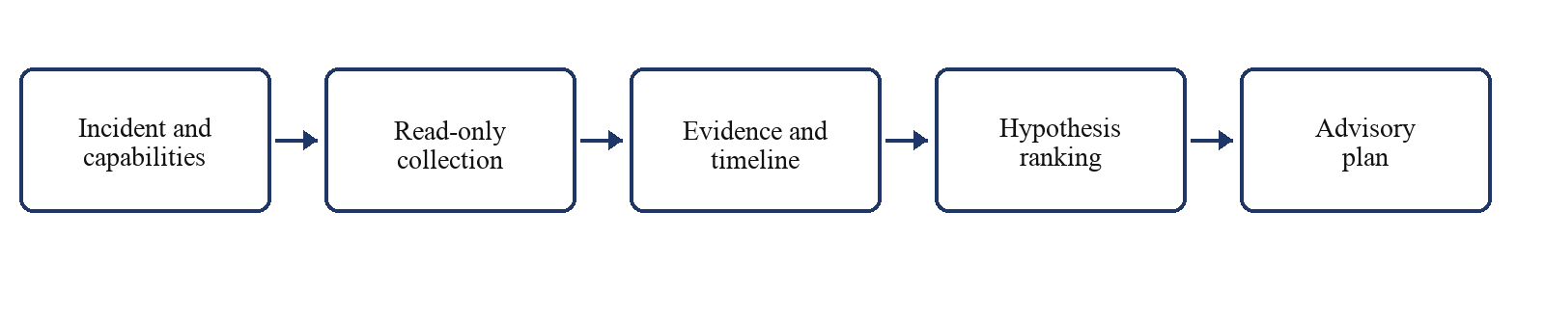
Figure 3.1 RecoverIT investigation workflow
3.3 INCIDENT INTAKE AND CONTRACTS
We use IncidentSeed as the canonical input. It records the incident identifier, affected service, environment, severity, detection and receipt times, and summary. Pydantic contracts validate data as it crosses module boundaries. Schema versions and canonical JSON help keep the meaning consistent between collection, evidence processing, timeline construction, and reasoning. By defining these fields explicitly, we reduce the ambiguity that would arise if each module interpreted a free-form incident description independently.
The source capability catalogue records what each configured adapter can supply. A query plan specifies the requested fields and time windows, and the collection service dispatches supported queries under concurrency and timeout limits. We report successful retrieval and collection failures separately. This allows the reasoning stage to discuss missing coverage without confusing it with an empty but successful result. The distinction matters when a diagnosis depends on a source that could not be reached during the investigation.
These contracts also constrain model-generated output. We require identifiers, timestamps, status values, and evidence references to fit the expected structure before later stages use them. Invalid data becomes an explicit failure or a blocked recommendation. We do not let a well-written explanation bypass the validation applied to other module outputs. This keeps the model within the application's data boundaries and makes malformed or unsupported output visible to the operator rather than silently incorporating it into the report.
3.4 SOURCE COLLECTION
We configure adapters for the source categories available in a particular runtime, such as logs, metrics, Git changes, deployments, pipeline records, and health signals. Live composition builds only the adapters named in the trusted configuration. Their declared capabilities let the query planner adapt to the actual deployment. We avoid assuming that every incident has every source, since a local demonstration and an integrated operational environment may provide very different evidence coverage.
We separate retrieval from interpretation. An adapter returns the original record identifiers and timestamps; it does not decide which record proves a cause. The collection service combines query results while preserving partial failures. If one source times out, the investigation can retain what other sources supplied and continue within its rules. The later stages then evaluate the available coverage explicitly. This arrangement makes source limitations part of the evidence assessment instead of allowing them to become either a crash or a misleading clean result.
We keep endpoints and credentials in server-side configuration. Operational records are treated as untrusted data, including any text that resembles an instruction to the model. Validation and redaction occur before the context is published for reasoning. Logs and configuration payloads may contain secrets or adversarial content, so their inclusion in a source record does not make them safe to repeat in a prompt or recommendation. The collection boundary retrieves information without granting that information control over the workflow.
3.5 EVIDENCE PROCESSING AND PROVENANCE
We normalize timestamps into a common UTC representation while retaining source event time and observation time. The evidence layer gives records stable identities, classifies their type, and derives a quality assessment. Original source identifiers remain available for tracing the record back to its origin. These steps let us compare observations across systems with different formats while preserving the distinctions needed to review them. A normalized record should be easier to use without obscuring where or when the underlying observation was made.
We consolidate repeated observations so that duplication does not inflate support for a hypothesis. Several copies of one log event should not count as several independent confirmations. The evidence repository stores normalized records and supports deterministic filtering, ordering, and pagination. This gives repeated investigations a consistent way to select and present the same evidence. It also supports review of the ranking, since the operator can inspect whether apparent corroboration comes from independent sources or from repeated records of the same event.
We redact sensitive content before summaries reach the reasoning services. Raw tokens or credentials should not appear in model prompts or final guidance. The published context includes evidence summaries and source coverage so that hypotheses can state what is supported and what is missing. Keeping both aspects visible is useful when a concise summary might otherwise give the impression that the investigation had complete access to the operational environment.
3.6 TIMELINE AND CONTEXT CONSTRUCTION
We build the timeline by mapping normalized evidence to typed events and ordering them by event time, with deterministic rules for ties. Temporal relationships describe sequence and association. We do not treat order alone as proof of causation. A deployment immediately before an error is relevant to the investigation, but the explanation still needs a mechanism and supporting records. This distinction lets the timeline organise evidence without making a stronger claim than the observations justify.
The context snapshot combines the incident seed, source coverage, evidence summaries, timeline events, and relationships. We use it as the defined information boundary for reasoning services. Those services assess the published context instead of reaching into source adapters arbitrarily. When more information is needed, the graph plans another collection round. This keeps retrieval visible in the workflow and helps us account for what evidence was available when a hypothesis was generated.
We need enough context to distinguish plausible causes without overwhelming the reasoning stage with unrelated material. Too little information invites speculation; excessive detail can obscure the causal evidence within the available records. The graph therefore assesses gaps and plans focused queries. After collection, it updates the context and considers whether another round is likely to be informative. The purpose of further retrieval is to resolve an identified uncertainty, not simply to increase the quantity of text supplied to the model.
3.7 INVESTIGATION GRAPH AND STATE
We compile the investigation as nodes for initialization, gap assessment, query planning, evidence collection, context building, hypothesis generation, stopping evaluation, ranking, and inconclusive completion. When remediation planning is configured, both completed and inconclusive paths reach the final plan node. An inconclusive investigation produces blocked change guidance with escalation and verification advice. This lets the application still provide a useful next step while acknowledging that it has not established a cause strongly enough to recommend a production change.
Conditional edges decide where the graph proceeds after query planning and stopping evaluation. It can return to collection while the budget permits, or finish with the best-supported result available under the stopping rules. We key persistent checkpoints by incident ID. The runner supports a new investigation and resumption from a saved state, allowing the application to retain progress without treating each invocation as unrelated work.
We deliver progress events through a task-local callback binding rather than placing callbacks in graph state. This helps keep concurrent investigations from sending one incident's updates to another client. Once the graph finishes, the runner returns a stable result with status, hypotheses, timeline, evidence, budget use, and any remediation guidance. The interface can display this result without having to interpret the graph's internal service objects or reconstruct the investigation independently.
3.8 HYPOTHESIS RANKING AND STOPPING
We represent each candidate with its suspected cause, affected component, supporting and contradicting records, and unresolved questions. The ranking engine calculates a reproducible score from defined evidence factors and penalties. Source independence prevents duplicate observations from appearing to be independent support. Symptom coverage checks whether the explanation accounts for the reported failure, temporal consistency checks the sequence, and change consistency considers relevant delivery evidence. These factors let us inspect why one explanation ranks above another instead of accepting an unexplained confidence value from the model.
Contradictions and missing causal evidence reduce the score. We distinguish support for the observed symptoms from support for the proposed cause because a hypothesis can describe the failure accurately without explaining what initiated it. The report therefore retains the factor breakdown and evidence references. We regard these as necessary for reviewing the ranking: a numerical score is useful only when the operator can see the observations and assumptions behind it.
We evaluate stopping conditions using the remaining budget, information sufficiency, and the quality of the available hypotheses. Abstention remains a valid outcome. A ranked list will always have a first item, but that position does not establish that the cause is known. By preserving an inconclusive status where appropriate, we prevent the presentation layer from turning a weak leading candidate into a confirmed diagnosis.
3.9 RECOMMENDATION-ONLY REMEDIATION
We request a typed candidate remediation plan from the configured reasoning provider. It may include prerequisites, descriptive actions, expected outcomes, verification checks, reversal guidance, and a risk category. We treat this as advice for a human reviewer. The current service does not execute its steps or issue infrastructure commands. Its role is to connect a supported diagnosis with a proposed next action in a form that can be assessed before an operator decides how to proceed.
We then validate the plan through deterministic policy. Low-confidence or contradictory diagnoses, unknown evidence identifiers, executable command syntax, and sensitive credentials can block the recommendation. Provider failures, including failure to return a usable result within the required conditions, lead to a blocked fallback. Inconclusive investigations receive escalation guidance. The validation is applied after generation so that the model cannot authorise its own recommendation by simply stating that the proposed steps are safe.
We deliberately limited this version to recommendation-only remediation. It gives us an interface for planning without assuming that approval handling, execution controls, or post-action checks have already been built. Those capabilities need their own implementation and evaluation. Keeping them outside the current runtime also makes the project's result clear: we can provide checked guidance, but we cannot claim that RecoverIT itself changed a service or verified its recovery.
3.10 INTERFACES AND DEPLOYMENT
We expose the same underlying investigation runner through several interfaces. The CLI accepts a runtime configuration and canonical incident file and can write a report. A FastAPI service makes the runner available to HTTP clients, while the web interface presents progress, status, evidence, and ranked results. We use these as different views of one application result. Their role is to make the investigation accessible, with the typed output and evidence records providing the common technical basis.
The live configuration specifies the provider and adapters, and invalid or missing settings are rejected. We can place checkpoint storage in an application data path and scope runs by incident identifier. This supports local demonstrations and controlled integration with external sources. The practical deployment still depends on the availability of those sources and the permissions granted to the application, so the configuration forms part of the investigation conditions.
Our development environment requires Python 3.11 or later. The runtime dependencies include Pydantic, FastAPI, httpx, LangGraph, and SQLite checkpoint support. We keep test dependencies separate so that the verification environment can supply its own fixtures and helpers without making them part of the live investigation path.
3.11 EVALUATION DESIGN
We currently use unit, contract, and integration tests to verify the behaviour of the implementation. A broader evaluation of diagnosis would require labelled incidents, known causes, source-availability information, and consistent experimental conditions. We would measure whether the cause is correct, whether citations refer to valid supporting evidence, and whether the system abstains appropriately when information is inadequate. We would also record elapsed investigation time and operational cost. These measures address the performance of the investigator as well as the correctness of its individual software components.
For a fair comparison, we would run a manual or rule-based baseline on the same incidents and source snapshots. Cases with missing sources, contradictory records, and large amounts of irrelevant log data should be examined separately. We would also grade recommendations for evidence support, safety, clarity, and useful verification guidance. These checks would precede any evaluation of action execution, since a recommendation must first be justified before its operational effect can be studied responsibly.
We do not claim a comparative RCA score for RecoverIT in this report. The test suite checks implemented contracts and flows, while the controlled case study in Chapter 4 shows one live investigation with a known fault. Neither establishes general production accuracy or a reduction in mean time to resolution. Those conclusions require a wider labelled evaluation with suitable baselines.
Module | Input | Output
Collection | Incident, source capabilities, query plan | Raw evidence batch
Evidence processing | Raw records | Normalized evidence and repository entries
Context | Evidence and incident | Timeline and context snapshot
Reasoning | Context and budget | Candidate hypotheses
Ranking | Candidates and evidence | Ranked hypotheses or inconclusive status
Remediation | Ranked output and context | Advisory plan or blocked guidance
Table 3.1 Module interfaces
Boundary | Control
External operational sources | Read-only registered adapters
Untrusted record content | Validation, normalization and redaction
LLM output | Typed contracts and deterministic ranking/policy
Production changes | No write-capable executor in current runtime
Table 3.2 Safety boundaries

CHAPTER 4
IMPLEMENTATION AND RESULTS
4.1 REPOSITORY IMPLEMENTATION
We organised the repository into contracts, collection, evidence, timeline, investigation graph, reasoning, remediation, and the RecoverIT application. The package metadata requires Python 3.11 or later and declares Pydantic, httpx, FastAPI, Uvicorn, LangGraph, and SQLite checkpoint support. The README explains installation and CLI use. Source modules implement the live workflow, while the docs directory records interfaces, design decisions, and handoffs. Some earlier documents describe a larger system than the one implemented for Project I. In this chapter, we report the current code and observed results so that those earlier proposals are not mistaken for completed features.
4.2 RUNTIME COMPOSITION AND GRAPH
We use recoverit.composition to validate the JSON runtime configuration and construct the graph with selected adapters and a real reasoning provider. It rejects automatic assembly of test or benchmark modes. Live runs use a SQLite checkpoint saver unless another backend is supplied, whereas tests may use an in-memory saver. The investigation.graph.builder module assembles ten named nodes. When a remediation planning service is configured, both the completed and inconclusive investigation paths are routed to that service, with the outcome determining what guidance it can return.
The recoverit.runner module starts the graph from a canonical incident and an investigation budget. It returns status, stop reason, ranked hypotheses, timeline events, evidence, provider identity, budget usage, and an optional remediation plan. We include a factor-level score breakdown in the Markdown report and label remediation as guidance requiring human review. The runner also exposes resumption by loading saved graph state for an incident ID. These outputs let an operator examine both the result and the conditions under which the investigation ended.
4.3 COLLECTION AND EVIDENCE
We implemented source-specific read-only adapters and the collection service in the collectors package. The evidence package validates their inputs, normalizes timestamps and record identities, redacts sensitive content, consolidates duplicates, and stores records through repository contracts. Timeline services map those records to events and relationships. We then publish a summarized, typed context for reasoning. This sequence keeps the origin of the data visible while giving the later stages a common representation to work with.
The separation between raw collection and normalized context is reflected in the package boundaries and tests. We avoid passing source-specific payloads directly into conclusions. Source status and warnings retain collection failures, allowing the investigation to account for unavailable information. This is particularly useful when a source returns nothing because it could not be reached: the system should recognise uncertainty rather than infer that no relevant event occurred.
4.4 REASONING AND RANKING
Our reasoning package contains the provider interface, live client, hypothesis services, ranking engine, and stopping logic. Fake and recorded providers support reproducible tests, but live composition does not select them implicitly. The ranking features consider independent source support, symptom coverage, temporal consistency, direct change evidence, specificity, and predicted observations. Contradictions and missing causal support incur penalties. This keeps the ordering of hypotheses tied to identifiable factors, even though the candidates themselves may be proposed by a language model.
We retain the final score and its components in the report. A reviewer can therefore see why the configuration explanation, for example, ranks above an infrastructure explanation and inspect the cited records. The score still depends on the available evidence and the candidate hypotheses considered. We do not interpret a high value as a calibrated probability that the diagnosis is correct. Establishing that relationship would require a labelled evaluation beyond the current verification.
4.5 REMEDIATION POLICY
Our remediation module currently generates recommendations only. It asks the reasoning provider for a candidate plan and checks the result against deterministic policy. Low confidence, contradictions, unknown evidence references, executable command syntax, or sensitive content can cause the plan to be blocked. Provider failures and inconclusive investigations return blocked guidance with escalation advice. We apply these conditions consistently so that a persuasive explanation does not override the controls attached to the plan.
The plan describes steps a human operator may review, including checks of the result and guidance for reversal where available. We have not implemented approval-ticket creation, infrastructure tool invocation, command execution, or measurement of recovery after an action. Those omissions define the current scope. The result of this stage is a policy-checked recommendation, and our conclusions do not treat it as an executed repair.
4.6 INTERFACES
We use the CLI to run an investigation from incident JSON and a runtime configuration, with the option to save a Markdown report. The HTTP service and web client present the same application result and progress information. We treat the interface as a view of the investigation. The evidence records and typed graph output remain the basis for examining what was collected, how the causes were ranked, and whether the final status was justified.
The runner's report includes ranked hypotheses, evidence scores, factor breakdowns, unresolved criteria where applicable, and advisory remediation. We designed this output so that a reviewer can compare the explanation with its sources. The recommendation can then be judged on the evidence available in that run, rather than on how convincing its wording appears in the interface.
4.7 TESTING AND VALIDATION
We tested the live investigation path using HarborShop, a separate checkout application running locally. Its initial revision stored product and order data in a provisioned SQLite directory. We then introduced a one-line configuration change that pointed the service to another storage directory that did not exist. This gave us a known fault and a clear basis for checking the diagnosis. We could compare RecoverIT's leading explanation with the actual change instead of deciding success from the appearance of the generated report alone.
We used the same traffic script for the healthy and faulty revisions. In the healthy run, all 15 valid checkout requests returned HTTP 201, and readiness returned HTTP 200. After the configuration change, all 15 valid checkout requests returned HTTP 500, while readiness returned HTTP 503. Liveness continued to return HTTP 200, and deliberately invalid checkout inputs still returned HTTP 400. The application and database logs recorded the failed requests and the database-file opening error. These observations established the behaviour of the test application independently of RecoverIT's investigation and showed which parts of the service remained responsive.
We then ran RecoverIT with local Git changes, versioned configuration, structured logs, the HTTP readiness check, and request metrics enabled as evidence sources. The live investigation completed in 16.45 seconds. Figure 4.1 shows the trace and incident summary presented by the interface. The use of several sources allowed us to inspect whether the final explanation connected the changed setting with the runtime failure.
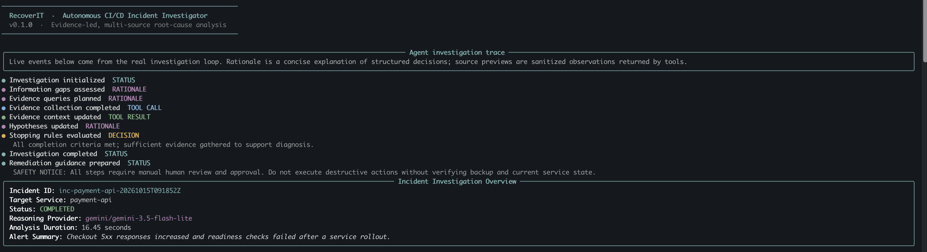
Figure 4.1 Live investigation trace and incident summary
The application ranked the order-storage path change first as a configuration regression, with an evidence score of 76.45 out of 100. It placed infrastructure failure second at 49.70. The leading explanation matched the one-line fault we had introduced and was consistent with the failed readiness checks. Figure 4.2 records the ranked hypotheses and their cited evidence. We interpret the displayed percentages as internal scores, not measured probabilities of correctness. The low symptom-confidence value also needs to be read in context because it depends on how individual log records are counted in this case. We therefore examined the factor breakdown alongside the leading label.
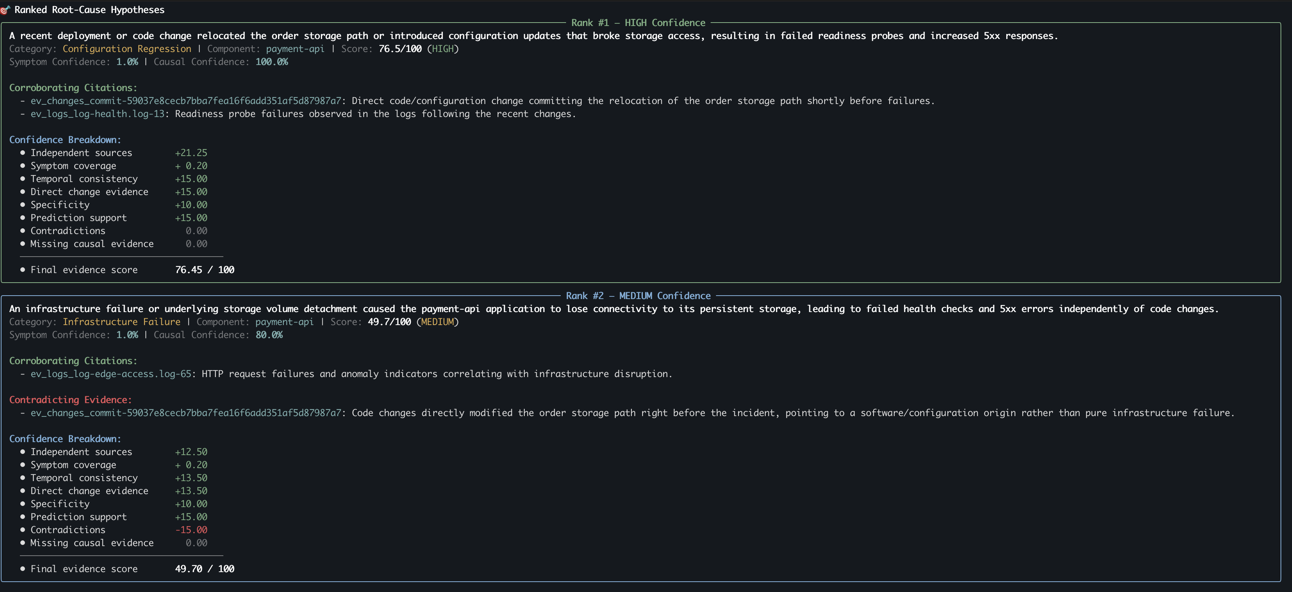
Figure 4.2 Ranked root-cause hypotheses for the controlled incident
RecoverIT also proposed steps for reviewing the configuration, checking readiness and application logs, correcting the storage path, and verifying recovery. Figures 4.3 and 4.4 show that guidance. We did not use RecoverIT to execute any change, and this run did not measure post-remediation recovery. Some suggestions referred generally to central dashboards or a deployment pipeline, although our case study used local logs and a local service. We retain that qualification because the operator would need to adapt those parts of the recommendation to the actual environment before acting.
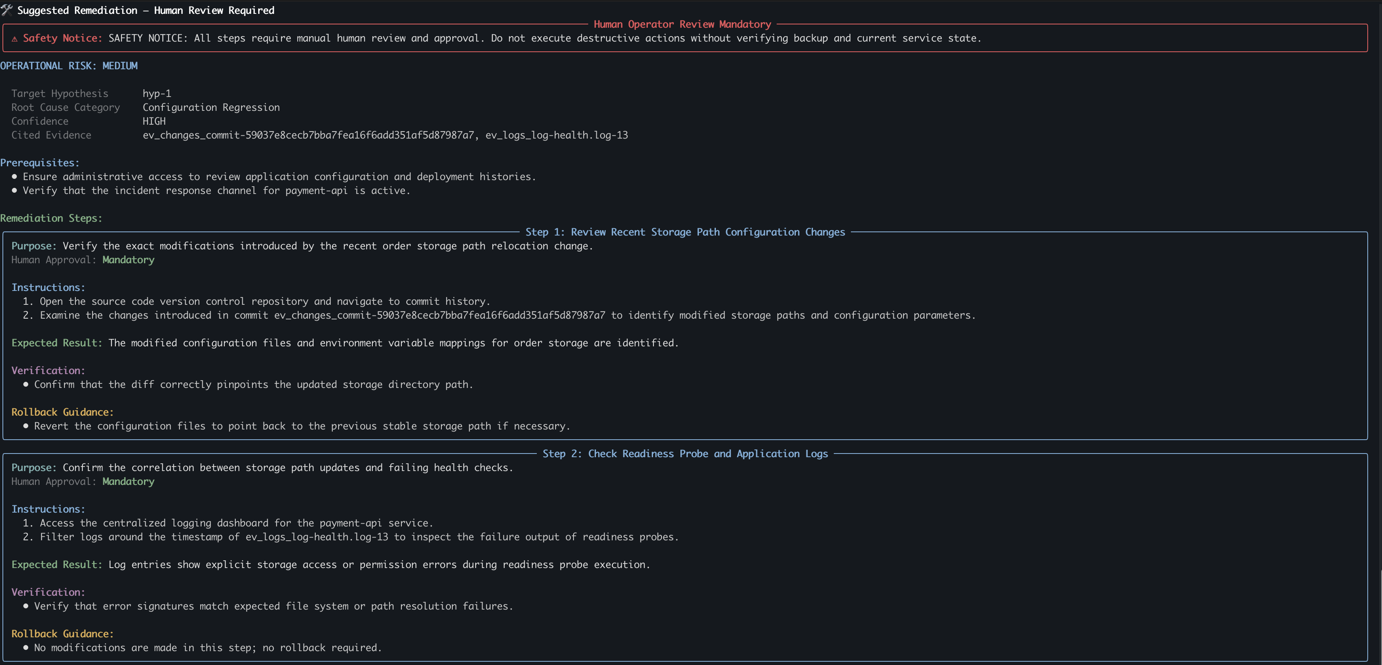
Figure 4.3 Advisory remediation output with review and log inspection steps
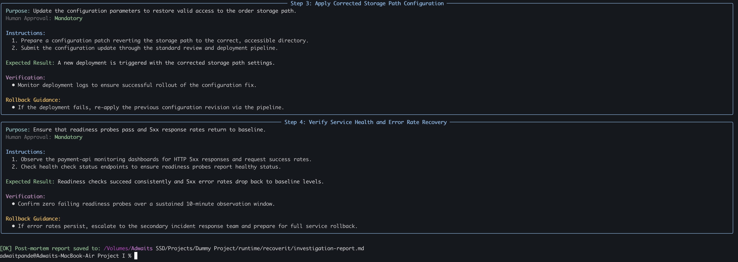
Figure 4.4 Advisory configuration and recovery verification steps
From this exercise, we can report that RecoverIT identified the known configuration fault in one controlled incident using live records from several sources. We cannot infer accuracy on unfamiliar incidents or a reduction in resolution time from that single result. The case study adds an application-level demonstration to the repository verification and shows how the evidence reaches the final diagnosis. A wider set of faults and comparison methods is still needed to assess general diagnostic performance.

4.8 RESULTS ANALYSIS AND LIMITATIONS
Our observed result is an integrated investigation workflow with typed boundaries, repository verification, and advisory remediation. The tests support the behaviour covered by their assertions, and the HarborShop case demonstrates one live path from evidence collection to a correct leading hypothesis. We have not compared RecoverIT with a human investigator or another diagnostic tool under matched conditions. We also did not measure a reduction in mean time to resolution. These limits prevent us from treating the successful demonstration as a general accuracy or efficiency result for production use.
The application remains limited by source coverage, telemetry quality, provider behaviour, and the candidate explanations generated during reasoning. Deterministic ranking addresses some failure modes, but it does not replace calibration against labelled incidents. Similarly, policy validation blocks specified classes of unsafe advice without establishing that every possible recommendation is safe. We would need a broader security assessment and a defined approval and execution design before allowing the application to make operational changes.
Our original self-healing title expresses the longer-term direction of the project. The current implementation ends with a recommendation that requires human review. We have no execution engine or closed loop that confirms recovery after a change. We make this distinction throughout the report so that the completed investigation work can be assessed on its own evidence, alongside the additional functions described in the proposal and literature.

CHAPTER 5
CONCLUSION AND FUTURE WORK
5.1 CONCLUSION
We developed RecoverIT to investigate CI/CD-related incidents within explicit evidence and resource boundaries. The application retrieves records from configured read-only sources, converts them into typed evidence, builds a timeline and incident context, and generates and ranks possible causes. Its report exposes the evidence factors behind the ordering. We use LangGraph for defined state transitions and checkpointing, while the interfaces make the result available for operator review. This gives us an implemented path from an incident input to a diagnosis that can be examined against the collected records.
We also implemented advisory remediation with deterministic policy checks. The application blocks change recommendations when confidence, evidence references, contradictions, or content-safety conditions do not meet policy requirements. For Project I, this establishes a controlled boundary between investigation and a human decision about action. The repository tests provide a passing verification baseline within their coverage, and the HarborShop exercise adds one controlled live example. Together, they support the implemented workflow while leaving broader questions about accuracy and operational benefit open for evaluation.
We have not demonstrated production-wide RCA accuracy, faster incident resolution, safe execution of infrastructure changes, or verified self-healing. These remain engineering and research objectives. Our conclusion is limited to the investigation and recommendation capabilities we implemented and the behaviour we observed, so that future work can be assessed against a clear starting point.
5.2 FUTURE WORK
Our next evaluation priority is a labelled incident set. It should include known causes, different source combinations, missing data, and contradictory observations. We would measure top-one and top-k diagnostic accuracy, evidence-reference correctness, confidence calibration, abstention quality, elapsed time, and provider cost. A manual or rule-based baseline should use the same immutable source snapshots. This would let us assess whether the application identifies the cause under controlled conditions and whether additional collection or reasoning provides a measurable benefit.
We also propose expanding source coverage and improving causal context. Additional adapters, service relationships, and links between deployments and changes may help explain incidents, but each addition should be tested for diagnostic value. More context is not automatically better context. Controlled experiments should determine whether a source helps distinguish causes or merely lengthens the prompt. We would include adversarial cases involving instructions embedded in logs, secret exposure, and misleading event order, since these challenge the boundaries between operational data and trusted application behaviour.
For future recovery, we would need an approved action catalogue, identity and permission checks, human confirmation where required, bounded execution, reversal safeguards, and observations after each action. These components must be implemented and evaluated together with the investigation they depend on. Only then could we examine whether RecoverIT reliably restores a service. Until that work is complete, we describe the application as an investigation assistant with advisory remediation.

